**Chapter 1**

**Parametric Equations and Polar Coordinates**

**1.4 Area and Arc Length in Polar Coordinates**

**Section Exercises**

**For the following exercises, determine a definite integral that represents the area.**

1. Region enclosed by 

Answer: 

1. Region enclosed by 

Answer: 

1. Region in the first quadrant within the cardioid 

Answer: 

1. Region enclosed by one petal of 

Answer: 

1. Region enclosed by one petal of 

Answer: 

1. Region below the polar axis and enclosed by 

Answer: 

1. Region in the first quadrant enclosed by 

Answer: 

1. Region enclosed by the inner loop of 

Answer: 

1. Region enclosed by the inner loop of 

Answer: 

1. Region enclosed by  and outside the inner loop

Answer: 

1. Region common to 

Answer: 

1. Region common to 

Answer: 

1. Region common to 

Answer: 

**For the following exercises, find the area of the described region.**

1. Enclosed by 

Answer: 

1. Above the polar axis enclosed by 

Answer: 

1. Below the polar axis and enclosed by 

Answer: 

1. Enclosed by one petal of 

Answer: 

1. Enclosed by one petal of 

Answer: 

1. Enclosed by 

Answer: 

1. Enclosed by the inner loop of 

Answer: 

1. Enclosed by  and outside the inner loop

Answer: 

1. Common interior of 

Answer: 

1. Common interior of 

Answer: 

1. Common interior of 

Answer: 

1. Inside  and outside 

Answer: 

1. Common interior of 

Answer: 

**For the following exercises, find a definite integral that represents the arc length.**

1. 

Answer: 

1. on the interval 

Answer: 

1. 

Answer: 

1. 

Answer: ]

**For the following exercises, find the length of the curve over the given interval.**

1. 

Answer: 

1. 

Answer: 

1. 

Answer: 

1. 

Answer: 32

1. 

Answer: 8

**For the following exercises, use the integration capabilities of a calculator to approximate the length of the curve.**

1. **[T]** 

Answer: 6.238

1. **[T]** 

Answer: 1.424

1. **[T]** 

Answer: 2

1. **[T]** 

Answer: 29.102

1. **[T]** 

Answer: 4.39

**For the following exercises, use the familiar formula from geometry to find the area of the region described and then confirm by using the definite integral.**

1. 

Answer: 

1. 

Answer: 

1. 

Answer: 

**For the following exercises, use the familiar formula from geometry to find the length of the curve and then confirm using the definite integral.**

1. 

Answer: 

1. 

Answer: 

1. 

Answer: 

1. Verify that if  then 

Answer: Use the product rule for derivatives.

**For the following exercises, find the slope of a tangent line to a polar curve  Let  and  so the polar equation  is now written in parametric form.**

1. Use the definition of the derivative  and the product rule to derive the derivative of a polar equation.

Answer: 

1.  

Answer: The slope is 0.

1.  

Answer: The slope is 

1.  

Answer: The slope is 

1.  

Answer: The slope is 0.

1.  

Answer: The slope is undefined.

1.  tips of the leaves

Answer: At  the slope is undefined. At  the slope is 0.

1. ; tips of the leaves

Answer: At  , the slope is . At  , the slope is . At  , the slope is .

1.  

Answer: The slope is undefined at 

1. Find the points on the interval  at which the cardioid  has a vertical or horizontal tangent line.

Answer: Horizontal tangent lines occur at  Vertical tangent lines occur at  and 

1. For the cardioid  find the slope of the tangent line when 

Answer: Slope = –1.

**For the following exercises, find the slope of the tangent line to the given polar curve at the point given by the value of **

1. 

Answer: Slope is 

1.  

Answer: Slope is 

1.  

Answer: The slope is  or approximately 1.019.

1. **[T]** Use technology:  at 

Answer: Calculator answer: –0.836.

**For the following exercises, find the points at which the following polar curves have a horizontal or vertical tangent line.**

1. 

Answer: Horizontal tangent at   vertical tangent at 

1. 

Answer: Horizontal tangent at  

1. 

Answer: Horizontal tangents at  vertical tangents at 

1. The cardioid 

Answer: Horizontal tangents at  Vertical tangents at  and also at the pole 

1. Show that the curve  (called a *cissoid of Diocles)* has the line  as a vertical asymptote.

Answer: Algebraically, find  and determine the values at which the denominator is equal to zero (but not the numerator). Geometrically, the sketch indicates a vertical asymptote at 

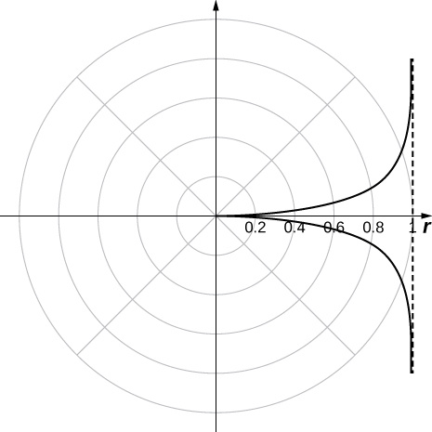

This file is copyright 2016, Rice University. All Rights Reserved.